# PLUGGING INTO THE FUTURE: AN EXPLORATION OF ELECTRICITY CONSUMPTION PATTERNS

INTRODUCTION

India is the world’s third-largest producer ad third-largest consumer of electricity.

The dataset is exhaustive in its demonstration of energy consumption state wise.

Analysing electricity consumption in India from Jan 2019 till 5th December 2020. This dataset contains a record of electricity consumption in each state of India, here we are going to analyse state wise, region wise and overall electricity consumption in India.

PURPOSE

* Enlightenment of electricity consumption analysis

* Learned about data analytics with tableau

* Electric energy consumption is the actual energy demand made on existing electricity supply for transportation, residential, industrial, commercial, and other miscellaneous purposes.

PROBLEM DEFINITION & DESIGN THINKING

1. Empathy map

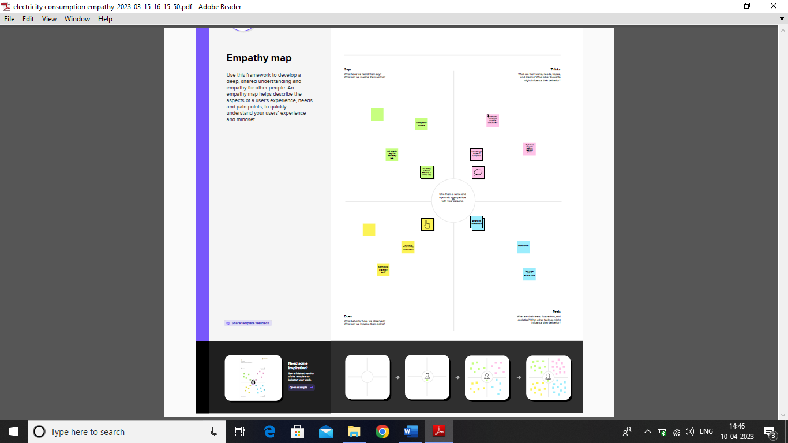

1. Ideation & Brainstorming Map

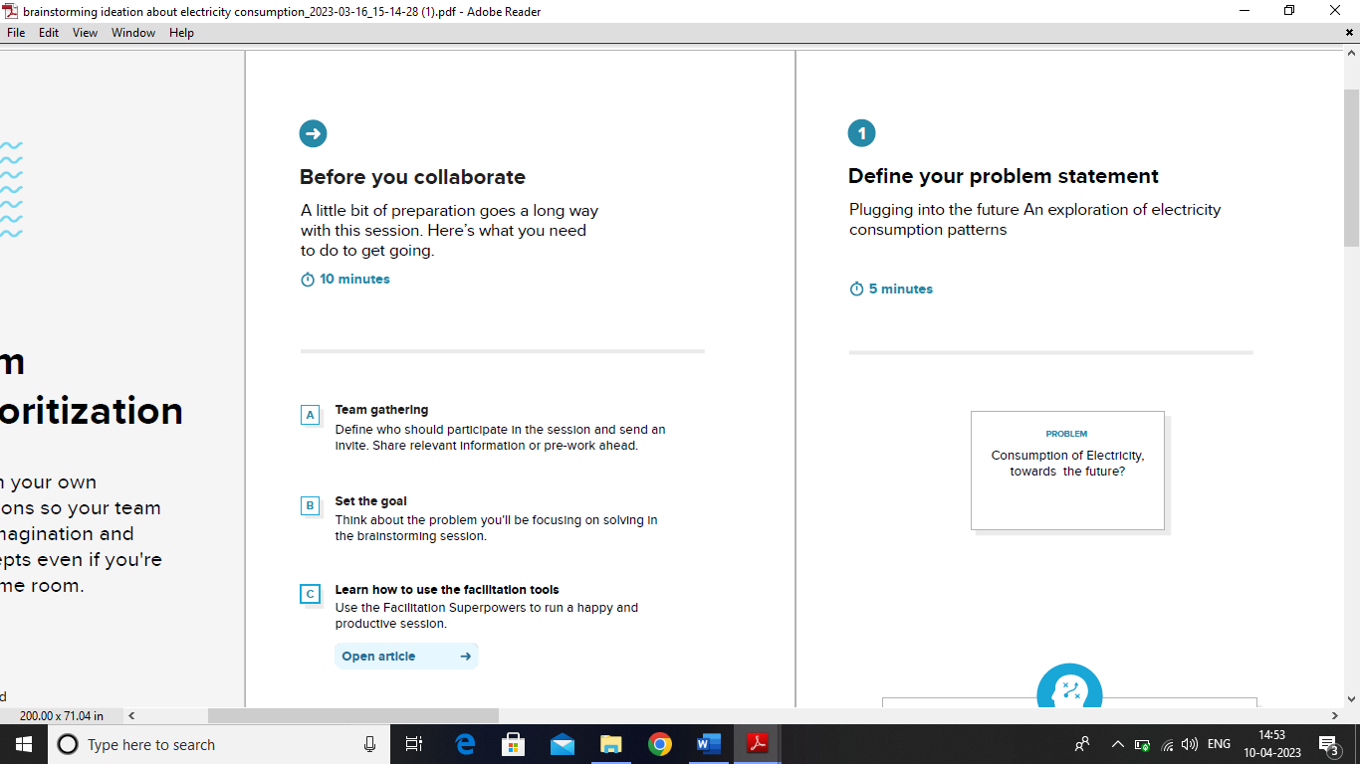

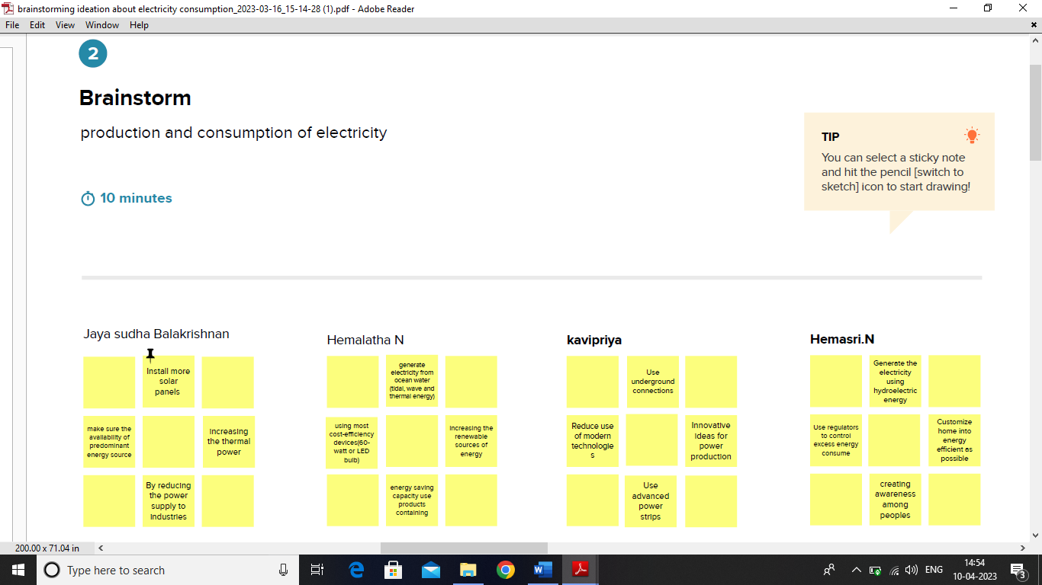

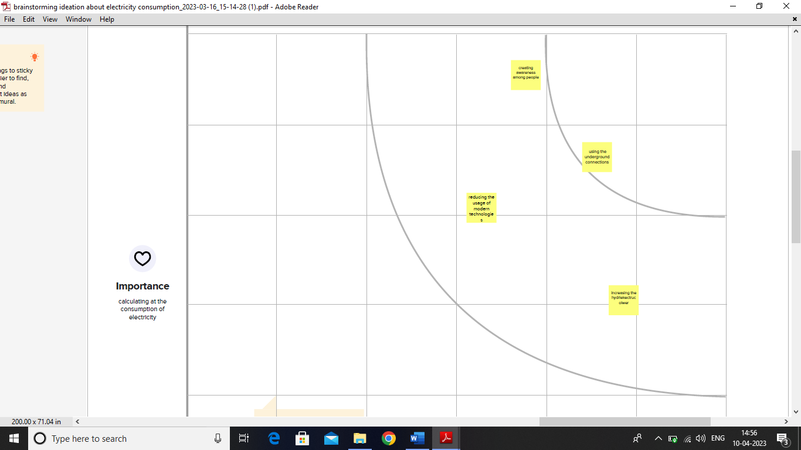

Result

The final output of flask embedding and web integration.

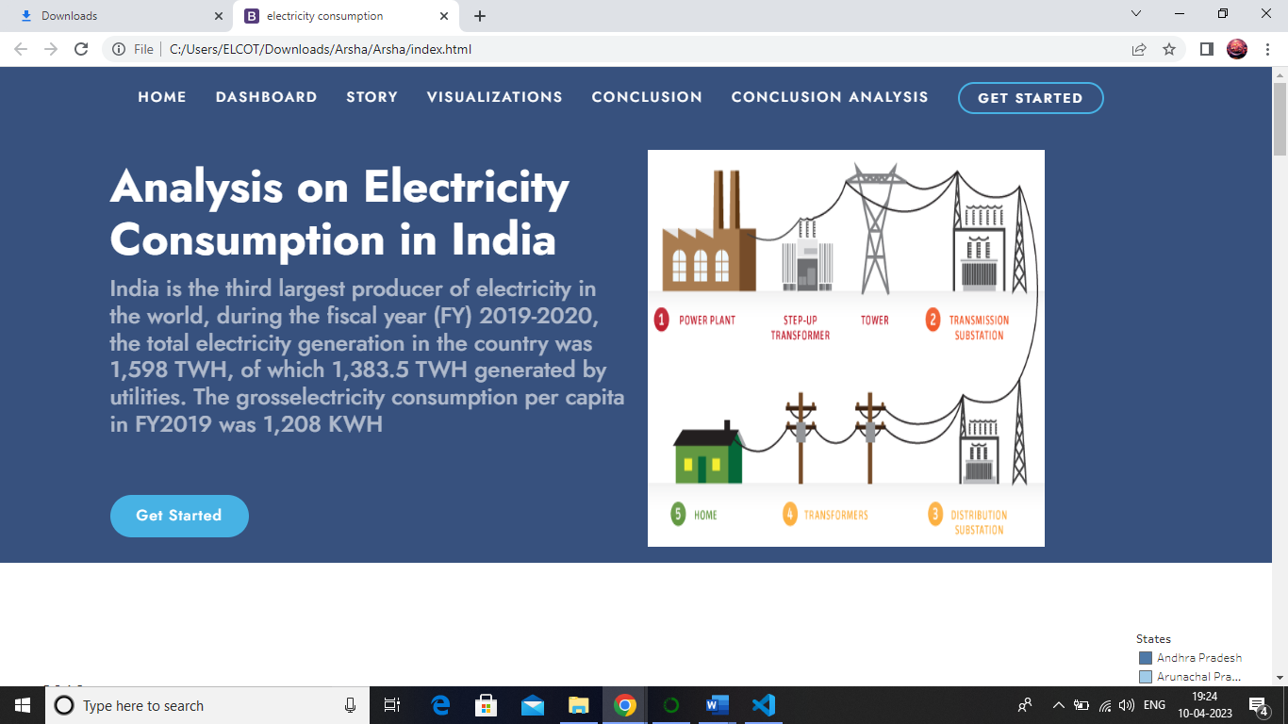

ADVANTAGES & DISADVANTAGES

Electricity consumption has both advantages and disadvantages for the future. Here are some of them:

Advantages:

* Renewable energy sources such as solar and wind power can reduce carbon emissions from traditional energy sources like coal and gas, which is better for the environment.
* Electricity is essential for many industries and is necessary to power many technological devices that improve our lives and make our societies more efficient.
* As technology continues to advance, the potential for energy storage and smarter energy systems may make electricity production even more efficient and reliable.

Disadvantages:

* Fossil fuels, which are still a major source of energy, contribute to air pollution and climate change.
* There is a risk of power outages and blackouts due to increased demand for electricity.
* The production and distribution of electricity can be expensive, particularly for those in developing countries or low-income households.

Overall, it is important to consider the long-term effects of electricity consumption and work towards sustainable sources of energy.

APPLICATIONS

The consumption of electricity is a crucial topic to consider as we look towards the future. Here are some potential applications and considerations regarding the consumption of electricity:

* Renewable energy sources - as the world moves towards greater use of renewable energy sources, such as wind and solar power, the consumption of electricity will likely shift increasingly towards these sources.
* Smart grid technology - this technology allows for more efficient monitoring and control of electricity use, potentially reducing energy waste and providing cost savings.
* Electric vehicles - as electric vehicles become more prevalent, the demand for electricity to power them will increase, posing both opportunities and challenges for the electricity grid.
* Energy storage - the development of more efficient and cost-effective energy storage technologies can help smooth out the variability of renewable energy sources and reduce the need for new power plants.
* Energy efficiency - reducing overall energy consumption through improved energy efficiency practices and technologies can help reduce strains on the electricity grid and reduce costs for consumers.

Overall, moving towards a more sustainable and efficient use of electricity will be crucial for shaping a cleaner and more secure energy future.

CONCLUSION

In this project we analysed data of electricity consumption state wise, region wise and overall electricity consumption in India using Tableau. Finally, we made flask embedded and creating webpage for our project.

FUTURE SCOPE

The future scope for the consumption of electricity is expected to increase with the growing population, urbanization, and technological advancements. As more people move into cities and rely on electronic devices, the demand for electricity is expected to rise.

However, there is also a growing trend towards renewable energy sources such as solar, wind, and hydro power. This is due to concerns about the environmental impact of fossil fuels and the need to reduce greenhouse gas emissions. As technology improves and becomes more cost-effective, renewable energy sources are expected to become more accessible and widespread.

Smart grid technology is also expected to play a significant role in the future of electricity consumption. This technology can help to optimize the use of energy resources by monitoring energy usage and automatically adjusting power generation and distribution. Smart grids can also incorporate renewable energy sources and energy storage devices to create a more resilient and sustainable energy system.

Overall, the future of electricity consumption is likely to be shaped by a combination of factors such as population growth, technological advancements, and the increasing demand for renewable energy sources.

APPENDIX

SOURCE CODE OF THE SOLUTION BUILT

<!DOCTYPE html>

<html lang="en">

<head>

  <meta charset="utf-8">

  <meta content="width=device-width, initial-scale=1.0" name="viewport">

  <title>electricity consumption</title>

  <meta content="" name="description">

  <meta content="" name="keywords">

  <!-- Favicons -->

  <link href="assets/img/favicon.png" rel="icon">

  <link href="assets/img/apple-touch-icon.png" rel="apple-touch-icon">

  <!-- Google Fonts -->

  <link href="https://fonts.googleapis.com/css?family=Open+Sans:300,300i,400,400i,600,600i,700,700i|Jost:300,300i,400,400i,500,500i,600,600i,700,700i|Poppins:300,300i,400,400i,500,500i,600,600i,700,700i" rel="stylesheet">

  <!-- Vendor CSS Files -->

  <link href="assets/vendor/aos/aos.css" rel="stylesheet">

  <link href="assets/vendor/bootstrap/css/bootstrap.min.css" rel="stylesheet">

  <link href="assets/vendor/bootstrap-icons/bootstrap-icons.css" rel="stylesheet">

  <link href="assets/vendor/boxicons/css/boxicons.min.css" rel="stylesheet">

  <link href="assets/vendor/glightbox/css/glightbox.min.css" rel="stylesheet">

  <link href="assets/vendor/remixicon/remixicon.css" rel="stylesheet">

  <link href="assets/vendor/swiper/swiper-bundle.min.css" rel="stylesheet">

  <!-- Template Main CSS File -->

  <link href="assets/css/style.css" rel="stylesheet">

  <!-- =======================================================

  * Template Name: Electricity consumption

  * Updated: Mar 10 2023 with Bootstrap v5.2.3

  * Template URL: https://bootstrapmade.com/arsha-free-bootstrap-html-template-corporate/

  * Author: BootstrapMade.com

  * License: https://bootstrapmade.com/license/

  ======================================================== -->

</head>

<body>

  <!-- ======= Header ======= -->

  <header id="header" class="fixed-top ">

    <div class="container d-flex align-items-center">

      <h1 class="logo me-auto" style="color: aliceblue;" ><a href="index.html"></a></Eh1>

        <nav id="navbar" class="navbar">

        <ul>

          <li><a class="nav-link scrollto active" href="#hero">Home</a></li>

          <li><a class="nav-link scrollto" href="#about">Dashboard</a></li>

          <li><a class="nav-link scrollto" href="#services">Story</a></li>

          <li><a class="nav-link   scrollto" href="#visual">visualizations</a></li>

          <li><a class="nav-link scrollto" href="#team">conclusion</a></li>

          <li><a class="getstarted scrollto" href="#about">Get Started</a></li>

        </ul>

        <i class="bi bi-list mobile-nav-toggle"></i>

      </nav><!-- .navbar -->

    </div>

  </header><!-- End Header -->

  <!-- ======= Hero Section ======= -->

  <section id="hero" class="d-flex align-items-center">

    <div class="container">

      <div class="row">

        <div class="col-lg-6 d-flex flex-column justify-content-center pt-4 pt-lg-0 order-2 order-lg-1" data-aos="fade-up" data-aos-delay="200">

          <h1>Analysis on Electricity Consumption in India</h1>

          <h2>India is the third largest producer of electricity in the world, during the fiscal year (FY) 2019-2020, the total electricity generation in the country was 1,598 TWH, of which 1,383.5 TWH generated by utilities. The grosselectricity consumption per capita in FY2019 was 1,208 KWH</h2>

          <div class="d-flex justify-content-center justify-content-lg-start">

            <a href="#about" class="btn-get-started scrollto">Get Started</a>

          </div>

        </div>

        <div class="col-lg-6 order-1 order-lg-2 hero-img" data-aos="zoom-in" data-aos-delay="200">

          <img src="assets/img/download.png" alt="img" height="421" width="421">

        </div>

      </div>

    </div>

  </section><!-- End Hero -->

  <main id="main">

    <!-- ======= Clients Section ======= -->

    </section><!-- End Cliens Section -->

    <!-- ======= About Us Section ======= -->

    <section id="about">

    <div class='tableauPlaceholder' id='viz1681008375851' style='position: relative'><noscript><a href='#'><img alt='Dashboard 1 ' src='https:&#47;&#47;public.tableau.com&#47;static&#47;images&#47;el&#47;electricityconsumptiondashboard_16808832311330&#47;Dashboard1&#47;1_rss.png' style='border: none' /></a></noscript><object class='tableauViz'  style='display:none;'><param name='host_url' value='https%3A%2F%2Fpublic.tableau.com%2F' /> <param name='embed_code_version' value='3' /> <param name='site_root' value='' /><param name='name' value='electricityconsumptiondashboard_16808832311330&#47;Dashboard1' /><param name='tabs' value='no' /><param name='toolbar' value='yes' /><param name='static_image' value='https:&#47;&#47;public.tableau.com&#47;static&#47;images&#47;el&#47;electricityconsumptiondashboard_16808832311330&#47;Dashboard1&#47;1.png' /> <param name='animate_transition' value='yes' /><param name='display_static_image' value='yes' /><param name='display_spinner' value='yes' /><param name='display_overlay' value='yes' /><param name='display_count' value='yes' /><param name='language' value='en-US' /></object></div>                <script type='text/javascript'>                    var divElement = document.getElementById('viz1681008375851');                    var vizElement = divElement.getElementsByTagName('object')[0];                    if ( divElement.offsetWidth > 800 ) { vizElement.style.width='100%';vizElement.style.height=(divElement.offsetWidth*0.75)+'px';} else if ( divElement.offsetWidth > 500 ) { vizElement.style.width='100%';vizElement.style.height=(divElement.offsetWidth*0.75)+'px';} else { vizElement.style.width='100%';vizElement.style.height='1827px';}                     var scriptElement = document.createElement('script');                    scriptElement.src = 'https://public.tableau.com/javascripts/api/viz_v1.js';                    vizElement.parentNode.insertBefore(scriptElement, vizElement);                </script>

    </section><!-- End About Us Section -->

    <!-- ======= Services Section ======= -->

    <section id="services" class="services section-bg">

      <div class='tableauPlaceholder' id='viz1681009124823' style='position: relative'><noscript><a href='#'><img alt='Story 1 ' src='https:&#47;&#47;public.tableau.com&#47;static&#47;images&#47;el&#47;electricityconsumption_16806080680770&#47;Story1&#47;1_rss.png' style='border: none' /></a></noscript><object class='tableauViz'  style='display:none;'><param name='host_url' value='https%3A%2F%2Fpublic.tableau.com%2F' /> <param name='embed_code_version' value='3' /> <param name='site_root' value='' /><param name='name' value='electricityconsumption_16806080680770&#47;Story1' /><param name='tabs' value='no' /><param name='toolbar' value='yes' /><param name='static_image' value='https:&#47;&#47;public.tableau.com&#47;static&#47;images&#47;el&#47;electricityconsumption_16806080680770&#47;Story1&#47;1.png' /> <param name='animate_transition' value='yes' /><param name='display_static_image' value='yes' /><param name='display_spinner' value='yes' /><param name='display_overlay' value='yes' /><param name='display_count' value='yes' /><param name='language' value='en-US' /></object></div>                <script type='text/javascript'>                    var divElement = document.getElementById('viz1681009124823');                    var vizElement = divElement.getElementsByTagName('object')[0];                    vizElement.style.width='100%';vizElement.style.height=(divElement.offsetWidth*0.75)+'px';                    var scriptElement = document.createElement('script');                    scriptElement.src = 'https://public.tableau.com/javascripts/api/viz_v1.js';                    vizElement.parentNode.insertBefore(scriptElement, vizElement);                </script>

    </section><!-- End Services Section -->

    <!-- ====== visual section ====== -->

    <section id="visual" class="vidual section-bg">

      <div class='tableauPlaceholder' id='viz1681087910169' style='position: relative'><noscript><a href='#'><img alt='Dashboard 5 ' src='https:&#47;&#47;public.tableau.com&#47;static&#47;images&#47;el&#47;electricityconsumptionvisual&#47;Dashboard5&#47;1_rss.png' style='border: none' /></a></noscript><object class='tableauViz'  style='display:none;'><param name='host_url' value='https%3A%2F%2Fpublic.tableau.com%2F' /> <param name='embed_code_version' value='3' /> <param name='site_root' value='' /><param name='name' value='electricityconsumptionvisual&#47;Dashboard5' /><param name='tabs' value='no' /><param name='toolbar' value='yes' /><param name='static_image' value='https:&#47;&#47;public.tableau.com&#47;static&#47;images&#47;el&#47;electricityconsumptionvisual&#47;Dashboard5&#47;1.png' /> <param name='animate_transition' value='yes' /><param name='display_static_image' value='yes' /><param name='display_spinner' value='yes' /><param name='display_overlay' value='yes' /><param name='display_count' value='yes' /><param name='language' value='en-US' /></object></div>                <script type='text/javascript'>                    var divElement = document.getElementById('viz1681087910169');                    var vizElement = divElement.getElementsByTagName('object')[0];                    if ( divElement.offsetWidth > 800 ) { vizElement.style.width='100%';vizElement.style.height=(divElement.offsetWidth*0.75)+'px';} else if ( divElement.offsetWidth > 500 ) { vizElement.style.width='100%';vizElement.style.height=(divElement.offsetWidth*0.75)+'px';} else { vizElement.style.width='100%';vizElement.style.height='727px';}                     var scriptElement = document.createElement('script');                    scriptElement.src = 'https://public.tableau.com/javascripts/api/viz_v1.js';                    vizElement.parentNode.insertBefore(scriptElement, vizElement);                </script>

    </section>

    <!-- ======= Team Section ======= -->

    <section id="team" class="team section-bg">

    <img src="assets/img/Table consumption.png" >

                <h1>Analysis on Electricity Consumption in India</h1>

                <p1>*Maharashtra is the Highest Electricity consumption user of India.<br>*Gujarat is the Secibd Highest Electricity consumption user of India.<br>*Sikkim is the Lowest Electricity consumption user in India.</p>

    </section><!-- End Team Section -->

  </main><!-- End #main -->

  <div id="preloader"></div>

  <a href="#" class="back-to-top d-flex align-items-center justify-content-center"><i class="bi bi-arrow-up-short"></i></a>

  <!-- Vendor JS Files -->

  <script src="assets/vendor/aos/aos.js"></script>

  <script src="assets/vendor/bootstrap/js/bootstrap.bundle.min.js"></script>

  <script src="assets/vendor/glightbox/js/glightbox.min.js"></script>

  <script src="assets/vendor/isotope-layout/isotope.pkgd.min.js"></script>

  <script src="assets/vendor/swiper/swiper-bundle.min.js"></script>

  <script src="assets/vendor/waypoints/noframework.waypoints.js"></script>

  <script src="assets/vendor/php-email-form/validate.js"></script>

  <!-- Template Main JS File -->

  <script src="assets/js/main.js"></script>

</body>

</html>